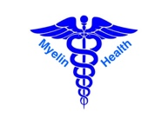
Medical / Cosmetic Questionnaire + Patient Registration Form:

Patient Name:
D.O.B.
Mobile:
Address:
Email:
GP / Family Practice:
Emergency Contact:
Emergency Ph:

Date: _________________________________

Proceduralist: Dr Hisam Zraika

Clinic: Blossom Cosmetics (Myelin Health Pty Ltd)

Relevant medical history: _________________________________________________________________

Medications: ___________________________________________________________________________

**Allergies:

Other Comments: _________________________________________________________________
PLEASE TICK if these apply | Yes | No | Details
Allergy to Anaesthetics OR adrenaline
(i.e. lidocaine)
Prev. Botox / Filler Hx.
Neurological disorders (myasthenia gravis / eaton lambert / MS / weakness undiagnosed)
Active autoimmune dx. (RA, SLE, Hashimotos)

Pregnancy or current IVF (if applicable)?

